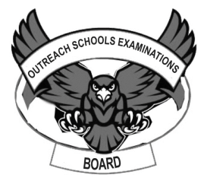

**OUTREACH SCHOOLS EXAMINATIONS BOARD**

**END OF TERM II EXAMINATION 2024**

**P.6 INTEGRATED SCIENCE**

***Time Allowed: 2hours 15 Minutes***

**Pupil’s Name: …………………………………………..……………………**

**Class: …………………………………….………………………………………**

**School Name: ………………………………………………………………….**

|  |  |  |
| --- | --- | --- |
| **FOR EXAMINERS’**  USE ONLY | | |
| **Qn. No.** | **MARKS** | **EXR’S**  **No.** |
| **1 - 10** |  |  |
| **11 – 20** |  |  |
| **21 – 30** |  |  |
| **31 – 40** |  |  |
| **41 – 43** |  |  |
| **44 – 46** |  |  |
| **47 – 49** |  |  |
| **50 - 52** |  |  |
| **53 - 55** |  |  |
| **TOTAL** |  |  |

**Read the following instructions carefully:**

1. This paper has two sections: **A** and **B**
2. Section **A** has 40 questions (40 marks)
3. Section **B** has 15 questions (50 marks)
4. Answer all questions. All the working for both sections A and B must be shown in the spaces provided.
5. All working must be done using a blue or black ball point pen or ink. Any work done in pencil will NOT be marked except drawings and diagram.
6. Unnecessary changes in your work and handwriting that cannot be easily read may lead to loss of marks.
7. Do not fill anything in the table indicated

**“For examiners’ use only”** and the boxes inside the question paper.

***Turn Over***

**SECTION A: 40 MARKS**

1. Why is it necessary for people to use soap when bathing?

……………………………………………………………………………………………………………………….

2. What sense organ enables the police dog to do its work?

……………………………………………………………………………………………………………………….

3. Besides alcohol, name any other drug that is commonly abused.

………………………………………………………………………………………….………………………….

4. State the name given to a female pig.

……………………………………………………………………………………………..……………………….

5. State the main source of light on earth.

……………………………………………………………………………………………………………………….

6. What name is given to a substance that can dissolve in a solvent?

…………………………………………………………………………….………………………………………….

7. Apart from carbohydrates, name one other class of food.

……………………………………………………………………….……………………………………………….

8. State any one method used to make dirty water clean.

……………………………………………………………………………………………………………………….

9. Apart from mosses, give one other example of a spore bearing non-flowering plant.

……………………………………………………………….…………………………………………………….

10. Sun birds visit flowers to get nectar. How do plants benefit from those birds?

…………………………………………………………….………………………………………………………….

11. What is the importance of dipping cattle?

…………………………………………………………….………………………………………………………….

12. Define soil erosion.

………………………………………………………….…………………………………………………………….

**The diagram below shows a crop rotation cycle.**

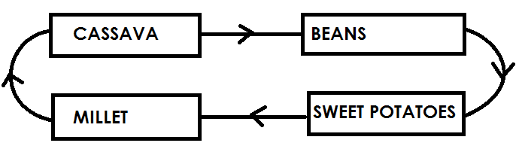

13. What is the importance of beans in this cycle to the rest of the crops?

……………………………………………………………………………….……………………………………….

14. Explain why one should chew food before swallowing it.

……………………………………………………………………………………………………………………….

15. Give the importance of the gills found in fish.

……………………………………………………………………….…………………………………………….

16. Write down any one property of air.

…………………………………………………………………………..………………………………………….

17. Name the digestive juice produced in the mouth.

…………………………………………………………………….………………………………………………….

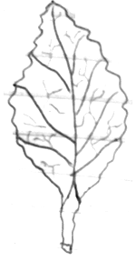18. Write down the type of venation shown by the diagram below.

.................................................................................

19. Why do we iron clothes before putting them on?

……………………………………………………………………………………………………………………….

20. Name any one raw-material needed for a plant to make starch.

……………………………………………………………………….……………………………………………….

21. State the importance of a clinical thermometer to a doctor.

……………………………………………………………………………………………………………………….

22. Identify any one natural source of sound in the environment.

……………………………………………………………..……………………………………………………….

23. Differentiate between a fruit and a seed.

…………………………………………………………………………….……………………………………….

24. How useful is the tongue in animals apart from tasting food?

………………………………………………………………………..…………………………………………….

25. How is the spread of diarrhoea and cholera similar?

……………………………………………………………………………………………………………………….

26. Name the major body organ responsible for pumping blood in the body.

……………………………………………………………………………………………………………………….

27. Name any one type of soil.

……………………..……………………………………………….…………………………………………….

28. Give one importance of scavenger birds to the environment.

……………………………………………………………………………………………………………………….

29. What are communicable diseases?

…………………………………………………………………………….………………………………………….

30. How do fungi reproduce?

……………………………………………………………..……………………………………………………….

31. Give one example of a root tuber.

……………………………………………………….……………………………………………………………….

32. Identify the breed of cattle with the body shape below.

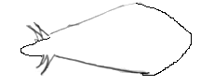...........................................................................

33. Identify the type of bee that fertilizes the eggs of the queen bee in a hive.

……………………………………………………………………………………………………………………….

34. Give one method of making clean water safe for drinking.

……………………………………………………………………………………………………………………….

35. A mother hung a black cloth and a white cloth of the same thickness. Which cloth dried last?

……………………………………………………….……………………………………………………………….

36. Mention one product got from pigs apart from pork.

……………………………………………………………………………………………………………………….

37. Define matter.

…………………………………………………………………..………………………………………………….

38. State the importance of the white blood cells in the body.

…………………………………………………………….……………………………………………………….

39. A cup full of water was left under sunshine all day long. What happened to the level of water?

……………………………………………………..…………………………………………………………….

40. Write a reason to support your answer in 39 above.

…………………………………………………………………………………………………………………….

**SECTION B:**

41. a) Define the term soil erosion.

……………………………………………………..……………………………………………………………….

b) Write two agents of soil erosion in a garden.

(i) …………………………………………………………….……………………………………………

(ii) …………………………………………………………………..…………………………………….

c) Give one way of controlling soil erosion.

……………………………………………………………………………………………………………………….

42. a ) State one reason why reptiles are classified under cold blooded animals.

………………………………………………………………..…………………………………………………….

b) How are reptiles important to people?

i) ………………………………………………….…………………………………………………………………

ii) ……………………………………………………………………………………………………………………

c) Give one similarity between reptiles and mammals in the way they breathe.

…………………………………………………………………………………………………………………….

43. **Use the diagram below to answer the questions that follow.**

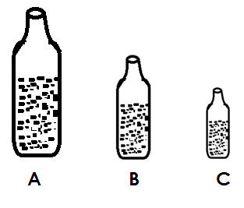

1. Which bottle above will produce the highest pitch of sound when air is blown in them?

……………………………………………………………….…………………………………………………

1. Give a reason to support your answer above.

………………………………………………………………………………………………………………….

c) Identify two factors that affect the pitch of sound.

i)…………………………………………………………..………………………………………………………….

ii) …………………………………………………………………………………………………………………….

44. a) Identify any two ways how roots are important to man.

(i) ……………………………………………………………………………………………………….

(ii) …………………………………………………………..…………………………………………….

1. Name one type of root system.

……………………………………………………………………..…………………………………………….

c) Give one example of crops with such a root system.

……………………………………………………………..…………………………………………………….

45. a) Mention the two types of immunity.

(i)...............................................................................................................

(ii)............................................................................................................

b) Suggest two ways a person can boost body immunity without using drugs.

(i) ………………………………………………………………………………………………………….

(ii) …………………………………………………………………………………………………………

46. a) Explain the term matter.

………………………………………………………………………………………………………………………

b) In which state of matter are the following substances?

(i) Ice........................................................................................................

(ii)water......................................................................................................

c) Name the instrument used to measure the temperature of sick persons.

..............................................................................................................

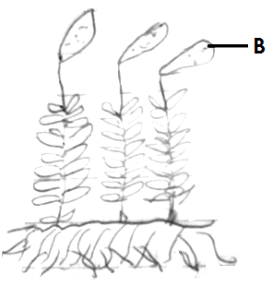47. **The diagram shows a non-flowering plant.**

a) Name the plant shown above.

...................................................................

b) What is produced in structure **B**?

...............................................................

...................................................................

c) Where are such plants normally found?

.................................................................................................................................

d) How is the above plant similar to a bean plant?

................................................................................................................................

48.a) Name any two examples of crop pests.

(i).............................................................................................................................

(ii)..............................................................................................................................

b) Apart from spraying with chemicals, give any other two ways of controlling crop pests.

(i) ..........................................................................................................................

(ii)........................................................................................................................

49. a) Mention two types of pollination in flowering plants.

(i) ..........................................................................................................

(ii) .........................................................................................................

b) Name any two agents of pollination.

(i) …………………………………………………………………………………………………….....

(ii) ......................................................................................................

50. a)Define “Breed of cattle.”

………………………………………………………………………………………………………………………………………………………………………..………………………………………………………………….

b) Give one reason why farmers breed their animals.

………………………………………………………….…………………………………………………………….

c) State any two methods of breeding in cattle.

(i) ……………………………………….……………………………….………………………………………

(ii) ………………………………………………………………………………………………………………….

51. **Match the body organ and the juice produced correctly.**

**List A List B**

**Stomach intestinal juice**

**Liver pancreatic juice**

**Pancreas bile juice**

**Walls of the ileum gastric juice**

a) Stomach : ……………………………………………………………………………………… ….

b) Liver : ……………………………………………….... ………………………………………

c) Pancreas : ………………………………............................. …………………………….

d) Walls of the ileum: ………………………………………………………………….………………

52. a) Explain what is meant by first aid.

……………………………………………………………..…………………………………………………….

……………………………………………………………………………..…………………………………………

b) List any two things found in the first aid box.

i) ……………………………………………………………………………………………………….....

ii) ………………………………………………………………..............................................

c) State one reason why every school should have a first aid box.

……………………………………………………….……………………………………………………………….

53. a) Write down two activities done to promote good sanitation in a

home.

i) ……………………………………………………………..…………………………………………

ii) ………………………………………………………………………………………………………..

b) Name any two diseases that may attack a family due to poor sanitation.

i) …………………………………………………………………………………………………………

ii) …………………………………………………………………………………………………………

54. a) What are poultry vices?

……………………………………………………………………………………………………………………..

…………………………………………………………………………………………………………………….

b) Write down two causes of poultry vices among poultry.

i) …………………………………………………………………………………………………………….

ii) ………………………………………………………………………………………………………….

c) How can a P.6 pupil control poultry vices on a farm.

……………………………………………………………………………………………………………………..

55. **The table below shows different groups of vertebrates. Use it to answer the questions that follow.**

|  |  |  |
| --- | --- | --- |
| **A** | **B** | **C** |
| **Birds** | **Mammals** | **Amphibians** |

a) To which group of vertebrates does each of the following belong?

i)Bat………………………………………………………………………………………………………

ii)Frog …………………………………………………………………………………………………….

b) How is the reproduction of animal in group A similar to animals in group C.

………………………………………………………………………………………………………………………..

c) Give any other group of vertebrate missing from the table above.

……………………………………………………………………………………………………………………

**END**